BSP MORB Compliance for Log360 Cloud
Automate BSP MORB compliance and fortify cybersecurity resilience for financial institutions with Log360.
Region: Philippines | Type: Financial Services | Category: Compliance | Pricing: Free

Overview
The BSP MORB compliance extension in Log360 helps organizations meet the Bangko Sentral ng Pilipinas Manual of Regulations for Banks, the primary regulatory compendium governing Philippine banks across capital adequacy, IT security, and cybersecurity requirements by providing centralized log management, real-time threat detection, and database activity monitoring. The platform supports BSP MORB requirements for information security governance, access management, privileged account monitoring, security event detection, network security, database auditing, audit logging, and third-party risk oversight.
For Information Security Governance, Log360 tracks policy changes, GPO modifications, system events, and computer auditing records to evidence governance control effectiveness for BSP examination. To address Access Management and Identity Controls, the platform monitors user logon events, failed authentication attempts, Active Directory access, remote desktop activity, and Unix system logons. The extension also supports Privileged Account and Admin Activity Monitoring by providing capabilities that tracks administrative account changes, user group modifications, SUDO command usage, password policy enforcement, and privileged session activities across banking systems.

Key Features
- Security Event Monitoring and Incident Response: Log360 provides threat detection from antivirus logs, FireEye and Trend Micro threat feeds, network attack reports, and Unix threat events with automated alerting.
- Network Infrastructure Security: Log360 captures network device configuration changes, firewall events, attack attempts, rule management activity, and policy management events across all banking network infrastructure.
- Database and Application Security: Log360 monitors database DDL and DML operations, logon events, permission denied reports, and comprehensive Oracle, MSSQL, and DB2 audit trails across banking systems.
- Audit Trail and Log Management: Log360 centralizes Windows event logs, process tracking, policy change records, and GPO audit trails to support BSP examination and compliance evidence.


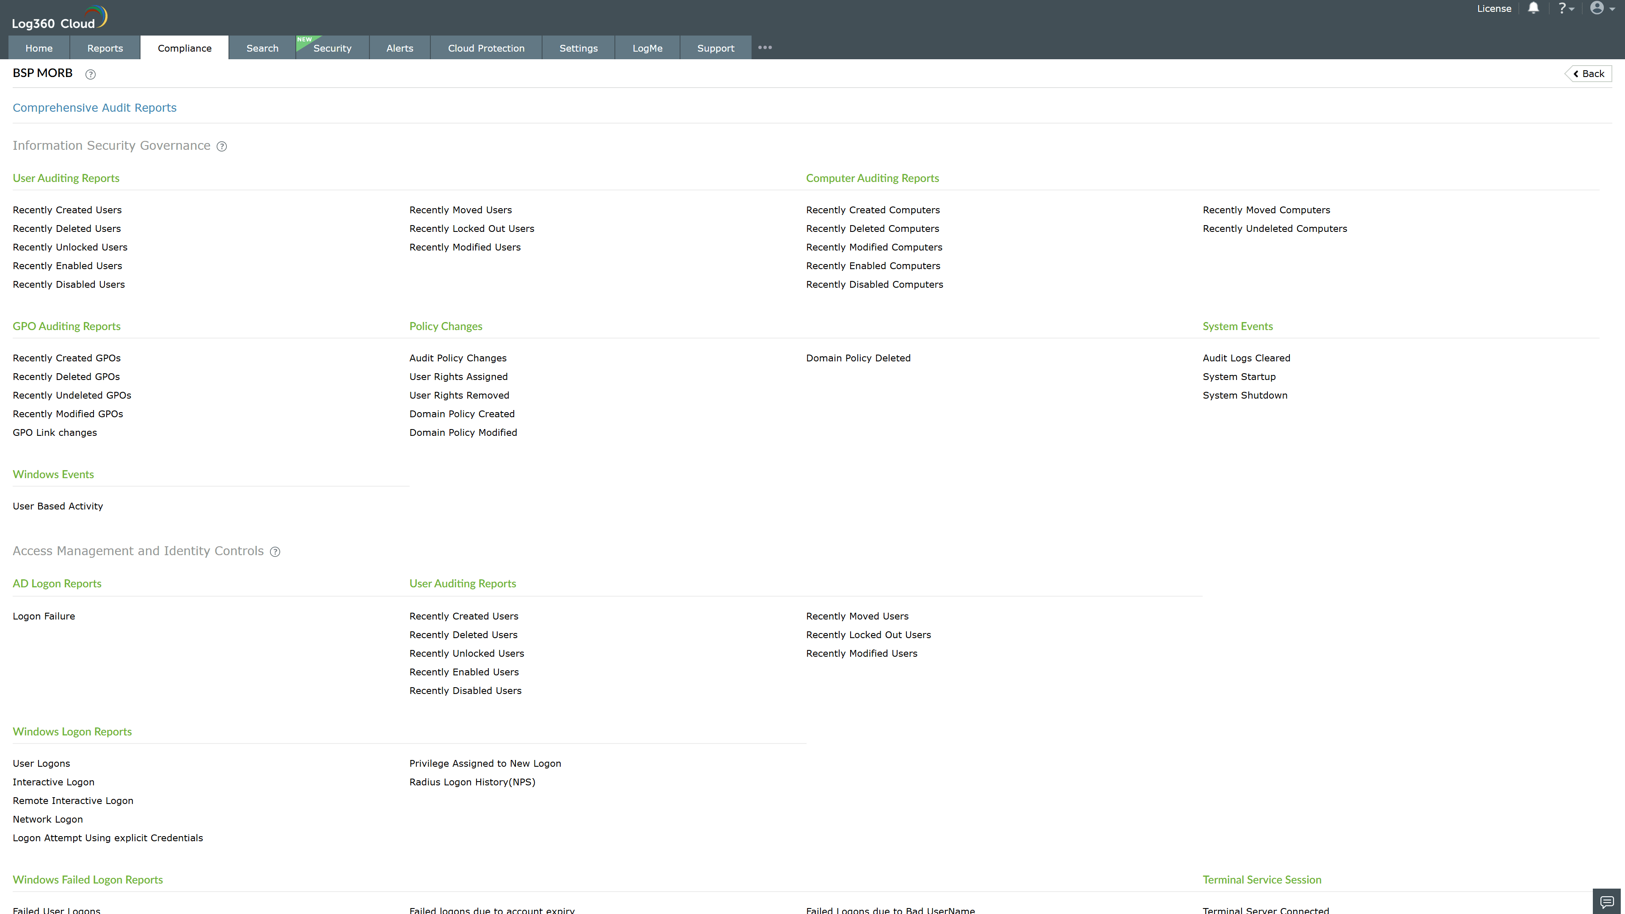
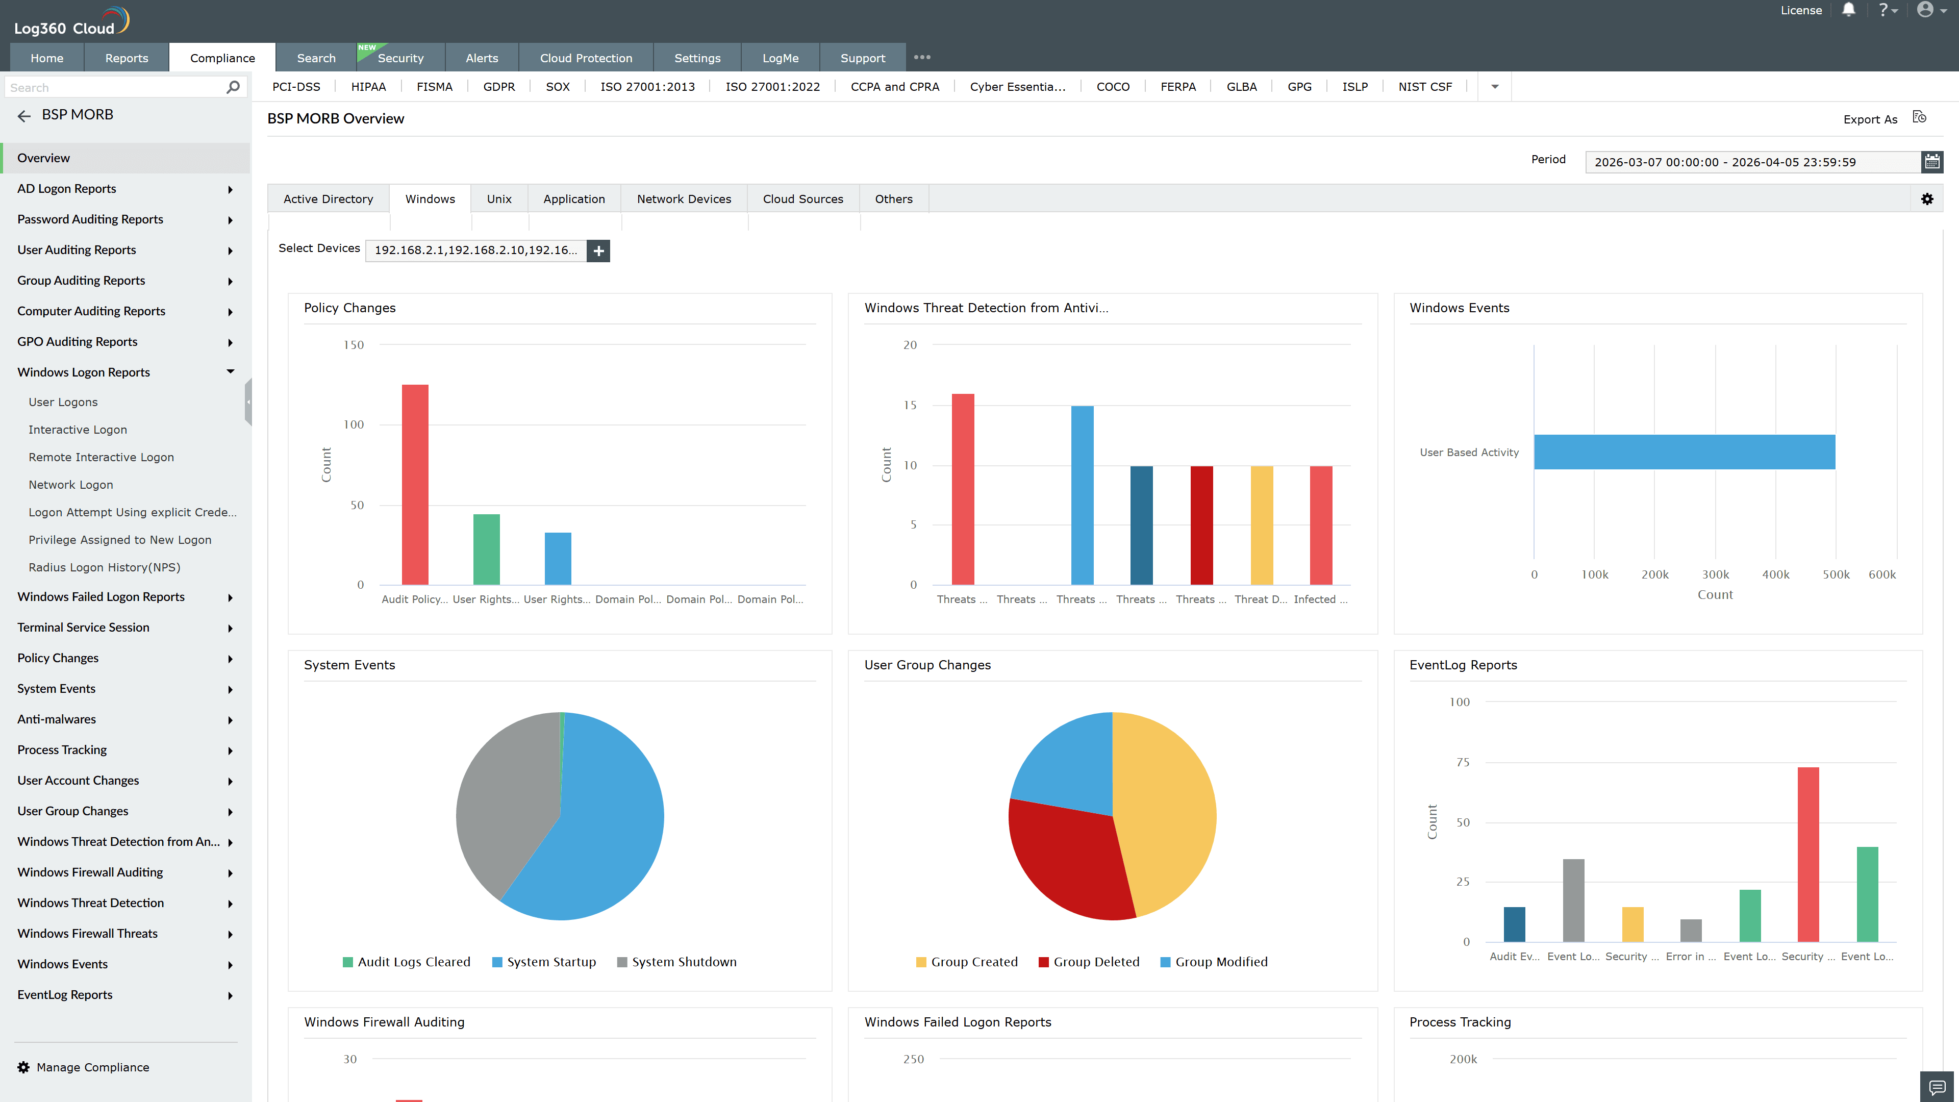
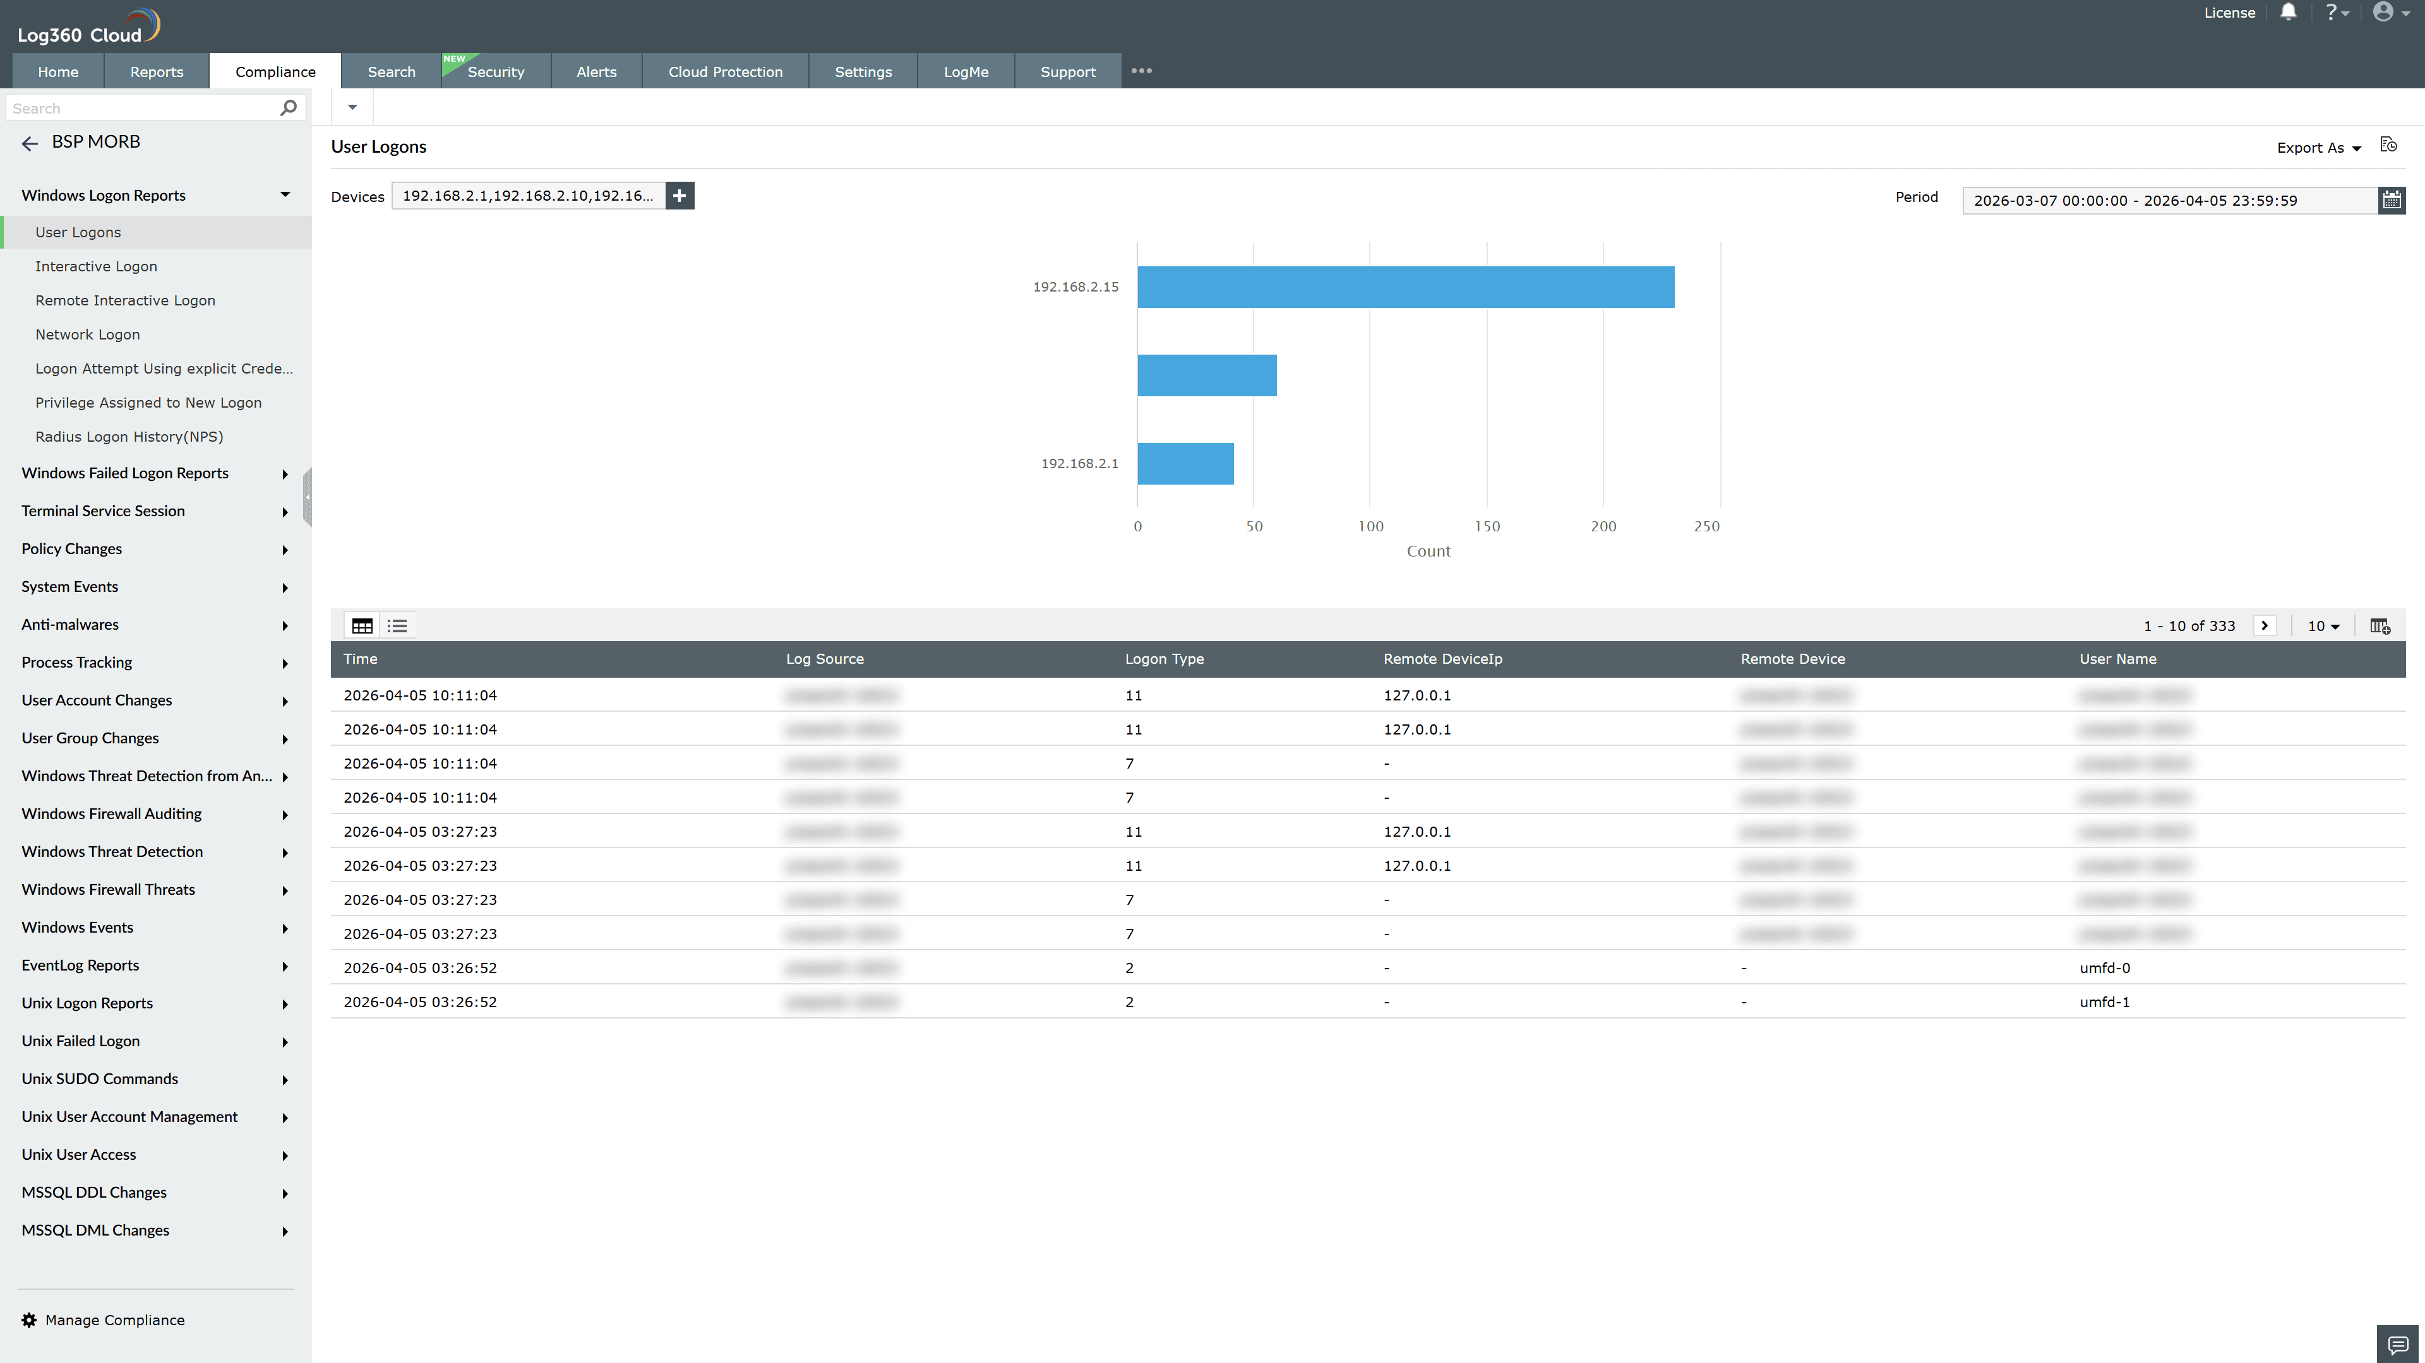
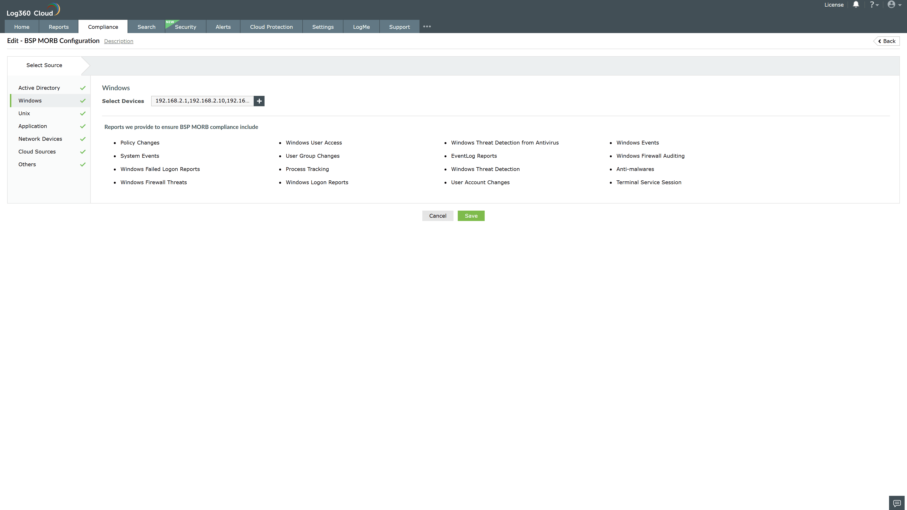
Valid Submission : Yes
Supported Editions : Free, Basic, Standard, Professional, MSSP
Help Document : https://www.manageengine.com/log-management/help/integrations/compliance-extensions.html
Help Video : Not provided
Tags : Log360, Compliance, Privacy monitoring, Data privacy, Regulatory compliance
Supported DCs : US, IN, JP, CA, AU, UK and EU
Privacy Policy:
Terms of Service:
Release Notes:
Predefined reports for the BSP MORB.

